Lab 2 Reflection

Proof
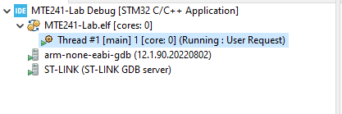
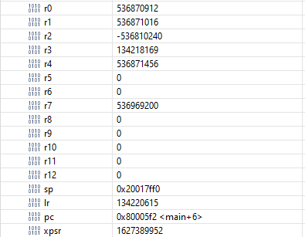

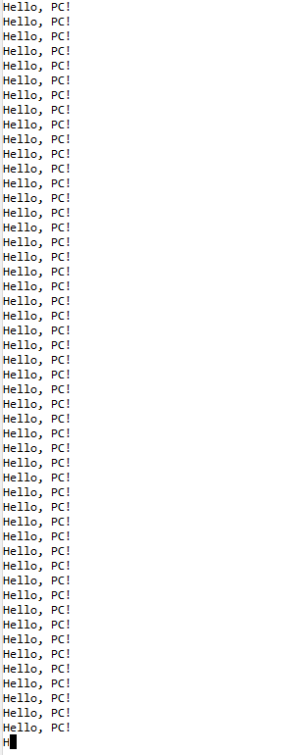

Question 1
In your own words, explain what happened in this lab when you changed PC to hold the function pointer to your print continuously function.

Answer:
When I changed the Program Counter (PC) to hold the function pointer to the print_continuously function, I effectively redirected the flow of execution to that function. The PC register holds the address of the next instruction the processor will execute. By directly assigning it the address of print_continuously, I caused the processor to jump immediately to that function. Specifically:
- Loading the Function Address into PC: I moved the address of print_continuously into the PC register.
- Immediate Execution of the Function: The processor fetched the instruction at this new address on the next cycle.
- Continuous Loop Execution: The print_continuously function began executing, entering its infinite loop that keeps printing "Hello, PC!".
- Override of Normal Flow: This direct manipulation bypassed the usual call stack and function call mechanisms.
This demonstrated how changing the PC can control program execution at a low level. It's similar to how an operating system switches between processes by changing the PC and other registers to point to different code segments. In the lab, this manipulation allowed us to see how we can start executing a function without a traditional function call, which is crucial for understanding context switching in operating systems.

Question 2
In your own words, explain what a system call is.

Answer:
A system call is a way for a program running in user mode to request a service from the operating system's kernel, which operates in a privileged mode. It's like a controlled gateway that allows applications to access protected resources and perform tasks they can't do directly, such as reading or writing to files, accessing hardware devices, or creating new processes.
When a program needs to perform such an operation, it makes a system call by executing a special instruction (like SVC on ARM processors). This instruction triggers a switch from user mode to kernel mode, allowing the operating system to safely execute the requested operation with the necessary privileges. After the operation is completed, control returns to the user program, often with a result or status code.
In our lab, we used system calls to execute specific functions within the kernel from our application code. For example, we created system calls that printed messages by invoking the SVC instruction with different numbers. This allowed us to perform operations that require higher privileges while maintaining system security and stability.

Question 3
Explain in your own words how the thread’s stack was set up. Comment on what it means to “set up a thread’s stack”, and why we need to store register values on the stack.

Answer:
Setting up a thread's stack involves preparing the memory and context the thread needs to run independently. Here's how we did it:
- Allocating Stack Memory: We obtained a new stack pointer (stackptr) pointing to a dedicated block of memory allocated for the thread's stack.
- Initializing the Stack Pointer: We set the Process Stack Pointer (PSP) to this new stackptr, so the thread uses its own stack separate from the main program.
- Pushing Register Values Onto the Stack: We manually pushed initial values onto the stack in a specific order: xPSR, PC, LR, and general-purpose registers (R12 to R0). The PC was set to the address of the thread's function (print_continuously), and xPSR was set with a default value.
By doing this, we created a "fake" context that makes it appear as if the thread had been interrupted and is about to resume execution. When the processor pops these values off the stack upon returning from the interrupt (system call), it loads the registers with the values we set, effectively starting the thread.
Why We Need to Store Register Values:
- Context Restoration: Storing register values allows the processor to restore the thread's context, ensuring it has all the necessary information to execute correctly.
- Independent Execution: Each thread needs its own set of registers to operate independently without interfering with other threads.
- Proper Function Execution: By setting PC to the thread's function and xPSR appropriately, we ensure the thread starts executing the correct code with the correct execution state.
Setting up a thread's stack is essential for multitasking, as it allows the operating system to switch between threads by saving and restoring their contexts, giving the illusion of parallel execution.

Question 4
In the switch/case in SVC_Handler_Main, we set PSP using the __set_PSP function before we could run the thread. If we didn’t do this, the code would crash in a hard fault. Explain why.

Answer:
Setting the Process Stack Pointer (PSP) using the __set_PSP function is crucial because it tells the processor which stack to use for the thread's execution. If we didn't set the PSP:
- Invalid Stack Pointer: The PSP would either be uninitialized or pointing to an incorrect memory location.
- Stack Operations Fail: When the processor tries to pop register values off the stack (like PC, LR, xPSR), it would access invalid or unintended memory areas.
- Hard Fault Occurs: Accessing invalid memory or executing an invalid instruction results in a hard fault, causing the system to crash.
In our lab, the SVC (Supervisor Call) handler uses the PSP to restore the thread's context from the stack. Without setting the PSP to point to our thread's stack (which we prepared), the processor wouldn't know where to find the saved register values needed to start the thread. This would lead to undefined behavior and a crash.
By properly setting the PSP, we ensure that the processor uses the correct stack memory for the thread, allowing it to load the correct context and execute without errors.

Question 5
Our thread function looped continuously. Assume that it didn’t, and instead, it simply printed something once and returned it. What would happen?

Answer:
If the thread function printed something once and then returned, several issues would arise:
- Invalid Return Address: The function would attempt to return to an address stored in the Link Register (LR). Since we manually set up the stack and may not have a valid return address in LR, the processor would jump to an undefined location.
- Undefined Behavior: Jumping to an undefined or invalid address could lead to executing random memory contents, causing a crash or unpredictable behaviour.
- Stack Corruption: The stack might not be correctly unwound, leading to corruption or misalignment, which can affect subsequent operations or threads.
- No Mechanism to Terminate the Thread: Since our simple operating system doesn't have a thread termination mechanism, the system wouldn't know that the thread has finished executing, potentially leading to resource leaks or scheduler issues.
In a fully-fledged operating system, when a thread finishes execution, it typically calls an exit function that cleans up resources, updates the scheduler, and possibly notifies other threads. Without such a mechanism, the thread returning would leave the system in an unstable state. This highlights the importance of handling thread termination properly in operating systems to maintain system stability.

Grading
Each question is evaluated based on the following scale.
Meets expectations: The answer is entirely correct. The answer is sufficiently detailed to include the major ideas necessary to prove that the student understands the concept. The answer is clear.
Approaching expectations: The answer contains no incorrect statements, but requires more detail or is too vague to convince the grader that the student understands the concept. The answer is clear.
Does not meet expectations: The answer either contains some incorrect statements or lacks detail to the degree that major portions of the question are left unanswered. The answer is not clear.
Not observed: the answer is largely incorrect or absent.
To get a grade for a question, you must obtain a rating of “meets expectations” on that question. You may resubmit as many times you like until you achieve that rating.

